Antibody Quality Control of non-phospho antibodies:

Name of Antibody: anti-Miro2 (human)

Sheep number: S247D

Immunogen: GST-MIRO2 (DU 38256)

Bleed number: 1st, 2nd and 3rd – immunoblotting
3rd bleed - immunoprecipitation

Immuno Blotting:

Vector control, Miro1-HA and Miro2-HA were transiently expressed in HEK 293 cells and whole cell lysates were made. 25ug of lysates were used to confirm specificity of the Miro2 antibody. 1ug/ml of anti-Miro2 antibody was used for immunoblotting. We expressed Miro1, an orthologue of Miro2 to see if the antibody can cross-react with Miro1.

The antibody specifically recognized over-expressed Miro2 and also recognized endogenous Miro2. Both endogenous and over-expressed protein ran at 75 kDa and we realized that Miro-HA over-expression is only twice as much as endogenous as we observe a slight increase in band intensity in the Miro2 over-expressed lane. We also used a commercial Miro2 antibody, which detects endogenous protein and we observe a similar scenario. The DSTT antibody was however more sensitive than the commercial Abnova Miro2 antibody.
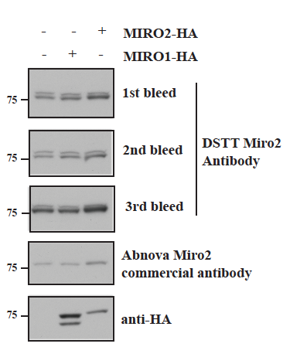
Immunoprecipitation

100ug of whole cell lysates from HEK293 cells was immunoprecipitated for endogenous Miro2 either using 5ug anti-Miro2 antibody covalently coupled to Protein-G sepharose beads or with 5ug pre-immune sheep IgG coupled to protein- G sepharose. 25ug of HEK 293 whole cell lysate was ran as an input control for the immunoprecipitation.

We observe that the Miro2 antibody can specifically pull-down endogenous Miro2 as we do not observe any band in the IgG control and we see a band of the correct molecular weight when the pull down was performed with Miro2 antibody.

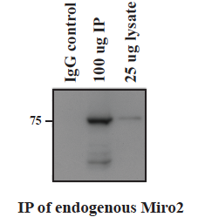

Amount used:
For immunoprecipitation of endogenous protein 5 ug of antibody per 100u g of cellular extract was used

